|  |  |
| --- | --- |
| **Project Title** | **CIVIL WORKS TO INSTALL NEW 24 CCTV CAMERAS AT ALBA** |
| **Document No** |  |
| **Contractor Name** | **AL AHLIA CONTRACTING COMPANY** |
| **Contractor Project Manager/contact details** | **RANGEETH RAVINDRAN (870810855)**  **MOB NO :-38307847** |
| **Contractor HSE Officer/contact details** | **SHINAS P K (950546119)**  **MOB NO:-33156741** |
| **Alba Responsible Engineer/contact details** | **LAYLA HASSAN** |
| **Purchase Order Number** | **S/45251119** |

|  |  |  |  |  |
| --- | --- | --- | --- | --- |
| **REV: 00** | **Prepared by** | **Initial Approval** | **Final Review** | **Final Approval** |
| **Date** | **01/02/2022** | **03/02/2022** |  |  |
| **Name** | **SHINAS P K** | **RANGEEETH RAVINDRAN** | **LAYLA HASSAN** | **ZAKARIYA AHMED** |
| **Designation** | **Contractor’s HSE Officer** | **Contractor’s Project Manager** | **Alba Responsible Engineer** | **Engineering SHE Coordinator** |

**Contents**

**1.** **Project Information** 2

**1.1** **Scope of work** 2

**1.2** **Location** 2

**1.3** **Project Schedule** 3

**1.4** **Contractor Organization Chart** 3

**2.** **Monthly Construction Activities** 3

**3.** **Safety, Health and Environment Monitoring Records** 3

**3.1** **Project Leading and Lagging Indicators** 3

**3.2** **Details of Incidents** 4

**3.3** **Key update on Safety, Health, Environment and Fire** 4

**3.4** **Waste Record** 4

**3.5** **Waste Water** 4

**3.6** **Spills Response and Contaminated Land** 5

**3.7** **Mock Drill Records on Fire, Safety, Health, Environment** 5

**3.8** **Training Record on Safety, Health and Environment** 5

**3.9** **Photos of SHE and Construction Activities** 6

**4.** **Attachments** 6

**4.1** **Monthly Site Inspection form completed (to including photos)** 6

**4.2** **Temporary site establishment inspection completed (if any).** 6

# **Project Information**

## **Scope of work**

The scope of work is to install CCTV cameras at road. All activities of Excavation, Reinstatement & Construction of Camera Pole Foundation is done for this. All the work is executed in accordance with Health, Safety & Environmental Action Plan

## **Location**



## **Project Schedule**

|  |  |  |
| --- | --- | --- |
| **Sl no:** | **Date** | **Activity** |
| 1 | 19-02-2022 | Removal of speed display unit |
| 2 | 22-02-2022 | Excavation for cable laying and reinstatement |
| 3 | 23-02-2022 | Installation of camera pole foundation and speed display unit |

## **Contractor Organization Chart**

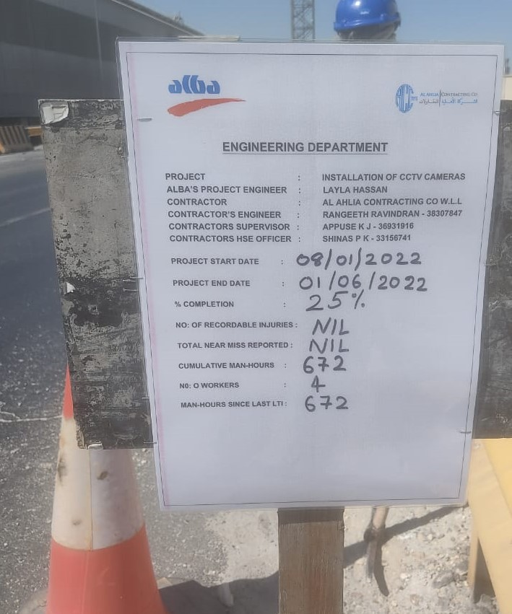

# **Monthly Construction Activities**

## **Activity 1**

**Rem** **oval of speed display unit**

Date:19/02/2022

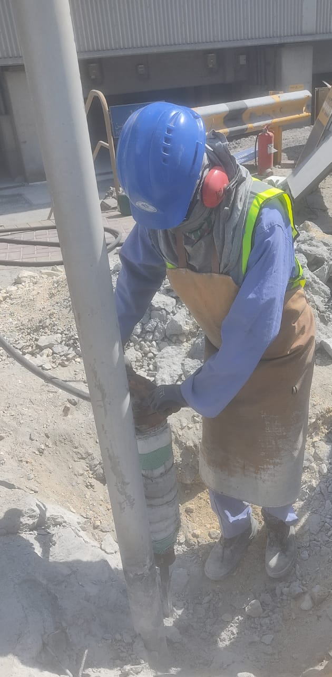

## **Activity 2**

Excavation for cable laying and reinstatement

Date: 22/02/2022

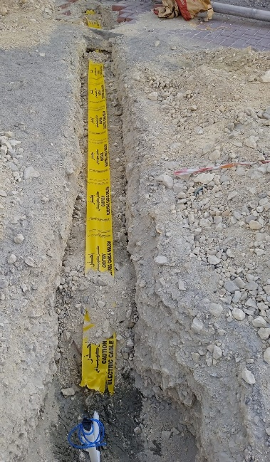 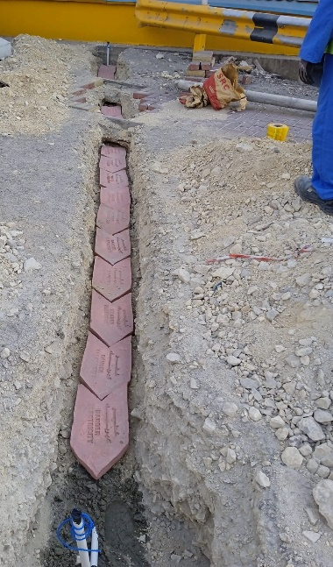

## **Activate 3**

**Installation of camera pole foundation and speed display unit**

Date: 23/02/2022

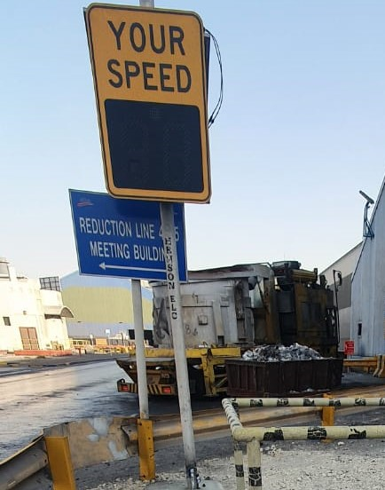 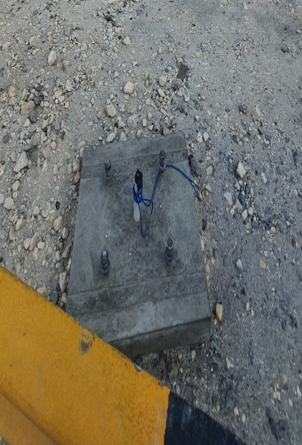 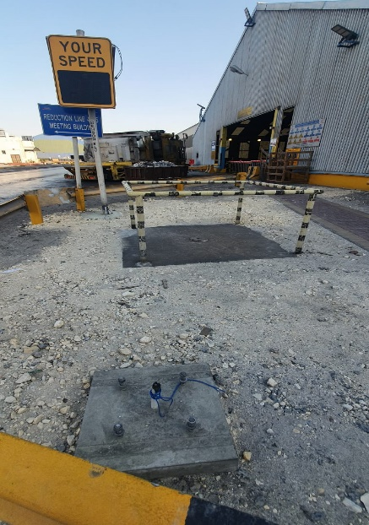

# **Safety, Health and Environment Monitoring Records**

## **Project Leading and Lagging Indicators**

|  |  |  |
| --- | --- | --- |
| **Lagging Indicators** | **Monthly** | **Inception to Date** |
| Work hours | 576 | 1008 |
| Work hours without LTI | 576 | 1008 |
| Lost Time Injury | NIL | NIL |
| Restricted Work Injury | NIL | NIL |
| Medical Treatment Injury | NIL | NIL |
| Recordable Injury* | NIL | NIL |
| First Aid Injury | NIL | NIL |
| LTI Frequency Rate ∞ | NIL | NIL |
| Recordable Injury Frequency Rate ∞ | NIL | NIL |
| Near Miss Recorded | NIL | NIL |
| High Potential Near Miss Recorded | NIL | NIL |
| Vehicle Incident | NIL | NIL |
| Property Damage | NIL | NIL |
| Environmental Incident | NIL | NIL |
| Fire | NIL | NIL |

* Recordable Injury = Lost Time Injury + Restricted Work Injury + Medical Treatment Injury

∞ Frequency Rate = Number of injuries per 200,000 hours worked

|  |  |  |  |
| --- | --- | --- | --- |
| **No.** | **Leading KPI** | **Monthly** | **Inception to date** |
| 1 | Number of Monthly HSE Meeting | 3 | 6 |
| 2 | Number of weekly site HSE inspections | 2 | 4 |
| 3 | Number of weekly tools/Equipment inspections | 2 | 5 |
| 4 | Number of employee received project induction | 1 | 5 |
| 5 | Number of weekly toolbox talks | 12 | 21 |
| 6 | Number of HSE walk-downs by project Management | 4 | 6 |
| 7 | Number of site observations | 8 | 8 |
| 8 | % of HSE corrective actions vs observation | 100% |  |
| 9 | % of training completed vs planned | 90% |  |
| 10 | HSE Training (Man-hours) | 1 | 1 |
| 11 | % of Mock drill plan compliance | NILL |  |
|  | Number of Average manpower | 5 | 5 |

## **Details of Incidents**

Nil

## **Key update on Safety, Health, Environment and Fire**

1. Daily tool box talk are taken before the work .We just summarize the details of the work, related hazards that can occur during the work and its preventive measures

## **Waste Record**

|  |  |  |  |  |  |
| --- | --- | --- | --- | --- | --- |
| **#** | **Type of Waste** | **Description of the Material** | **Quantity of Waste (Kg)** | **Transferred by Approved Waste Handler**  **(Yes or No)** | **Destination Name of Landfill/ Recycle/ Incineration facilities**  **(Provide Tracing Evidence) and photos** |
| **1** | Recyclable | NIL |  |  |  |
| **2** | Hazardous | NIL |  |  |  |
| **3** | Disposable | NIL |  |  |  |
| **4** | Incineration | NIL |  |  |  |
|  | **Total** |  |  |  |  |

## **Waste Water**

|  |  |  |  |  |
| --- | --- | --- | --- | --- |
| **#** | **Type of Waste** | **Quantity of Wastewater Transferred to STP (KL)** | **Transferred by Approved Waste Handler**  **(Yes or No)** | **Destination – Name of Sewage Treatment Plant** |
| **1** | NIL |  |  |  |
|  | **Total** |  |  |  |

## **Spills Response and Contaminated Land**

|  |  |  |  |  |  |
| --- | --- | --- | --- | --- | --- |
| **#** | **Spillage Event Explanation** | **Date of Spillage Event** | **Quantity of Hazardous Waste Stored at site (Kg)** | **Quantity of Hazardous Waste Transferred to Landfill (Kg)** | **Name of Landfill facilities** |
| **1** | Nil | Nil | Nil | Nil | Nil |
|  | **Total** | |  |  |  |

## **Mock Drill Records on Fire, Safety, Health, Environment**

|  |  |  |  |
| --- | --- | --- | --- |
| **Mock Drills No.** | **NIL** | **Date** |  |
| **Emergency Type** |  | | |
| **Location** |  | | |
| **Company** |  | | |
| **Scenario** |  | | |
| **Observations** |  | | |
| **Photos** |  |  | |

## **Training Record on Safety, Health and Environment**

| **Monthly** | | | | | |
| --- | --- | --- | --- | --- | --- |
| **Sl. No.** | **Trainings Course** | **Duration** | **Hours** | **Number of**  **Attendees** | **Total**  **Attendees** |
| **1** | Nil |  |  |  |  |
| **2** | Nil |  |  |  |  |
|  | **TOTAL** |  |  |  |  |

| **Inception to Date** | | | | | |
| --- | --- | --- | --- | --- | --- |
| **Sl. No.** | **Trainings Course** | **Duration** | **Hours** | **Number of**  **Attendees** | **Total**  **Attendees** |
| **1** | Nil |  |  |  |  |
| **2** | Nil |  |  |  |  |
|  | **TOTAL** |  |  |  |  |

## **Photos of SHE and Construction Activities**

|  |  |
| --- | --- |
| 1 | C:\Users\sekhar\Desktop\ccctv11.jpg |
| **Flag man assigned for safe traffic** |
| 2 | C:\Users\sekhar\Desktop\comprssor alba.jpg |
| **Compressor inspection** |
| 3 | C:\Users\sekhar\Desktop\cctv tbt.jpg |
|  | **Our daily TBT** |

* 1. **Next Month Safety Focus and planning**

We are planning to conduct a small class on safe manual lifting procedure and things to follow while working with ladder. We have observed small mistakes while manual lifting and ladder usage by the workers.

# **Attachments**

## **Monthly Site Inspection form completed**

**Compressor check list**

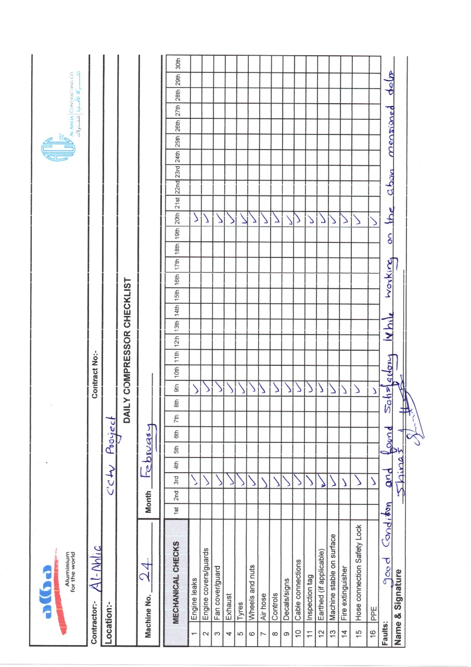

**Random PPE check list**

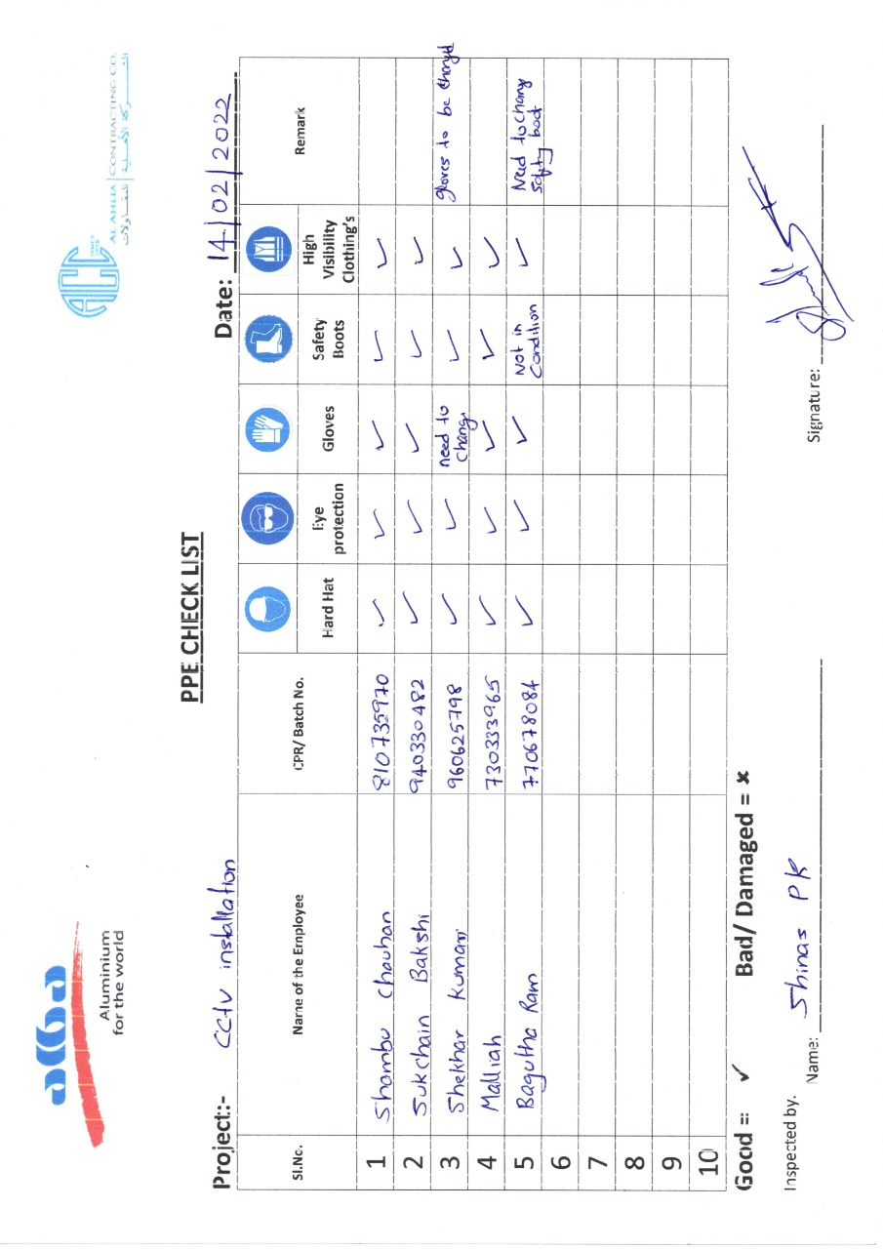

## **Temporary site establishment inspection completed**

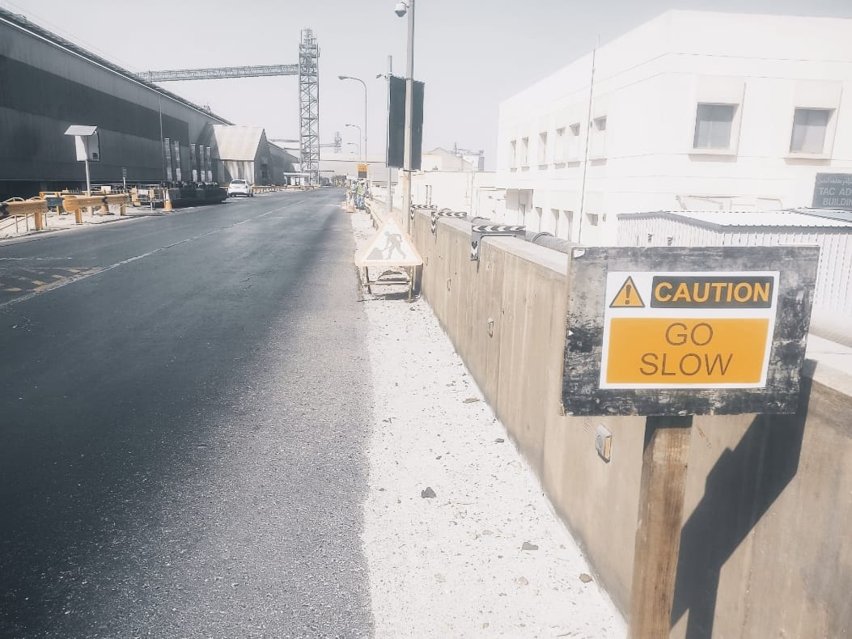

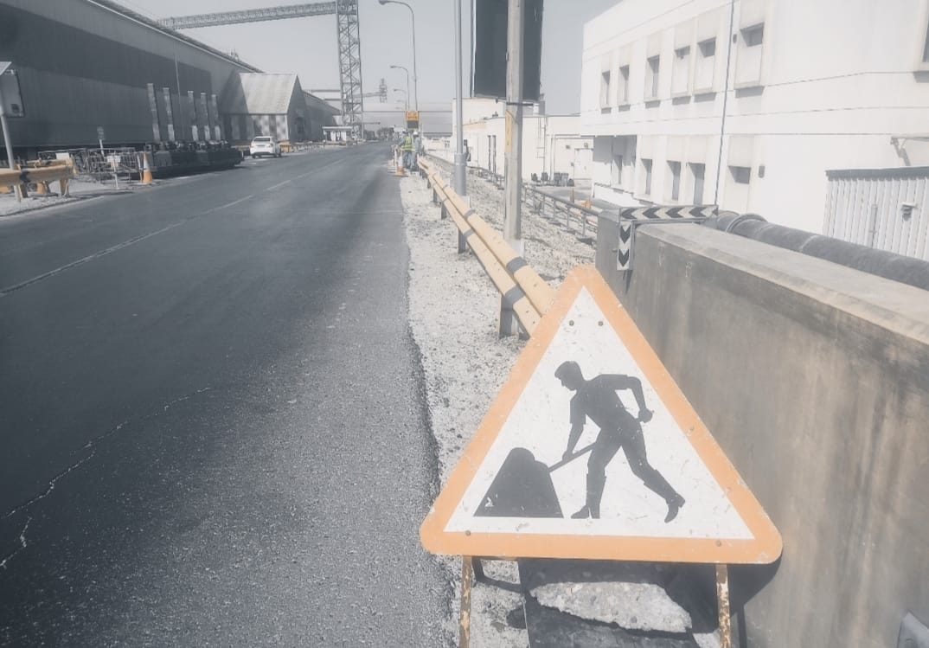

**Caution sign boards where kept for the safety of our team**